***INDEX***

|  |  |  |
| --- | --- | --- |
| ***Sr. No.*** | ***Topic*** | ***Page No.*** |
| ***1*** | ***Acknowledgement*** |  |
| ***2*** | ***Problem Statement*** |  |
| ***3*** | ***User Interface Screenshot*** |  |
| ***4*** | ***Database Screenshot*** |  |
| ***5*** | ***Use case*** |  |
| ***6*** | ***Future Implementation*** |  |
| ***7*** | ***Bibliography*** |  |

***Acknowledgement***

I would like to express my special thanks of gratitude to my teacher, **Prof. Pratiksha Rai** who gave me the golden opportunity to do this wonderful project on the topic **Book Movie Tickets**, which also helped me in doing a lot of Research and I came to know about so many new things I am really thankful to them.

Secondly I would also like to thank my parents and friends who helped me a lot in finalizing this project within the limited time frame.

***Problem Statement***

*Build a web application which is a BookMyMovie. This application provides ticket booking for the film running currently in the city. The system will be so simple and attractive which will make the audience, viewers comfortable to use and choose their movie.*

***Software Requirements***

|  |  |
| --- | --- |
| *Front end/GUI tools* | *.Net technologies*  *(visual studio 2010)* |
| *Back end* | *Sqlserver / microsoft access* |
| *Language* | *C#* |

***USER INTERFACE SCREENSHOT***

1. ***Home Page***

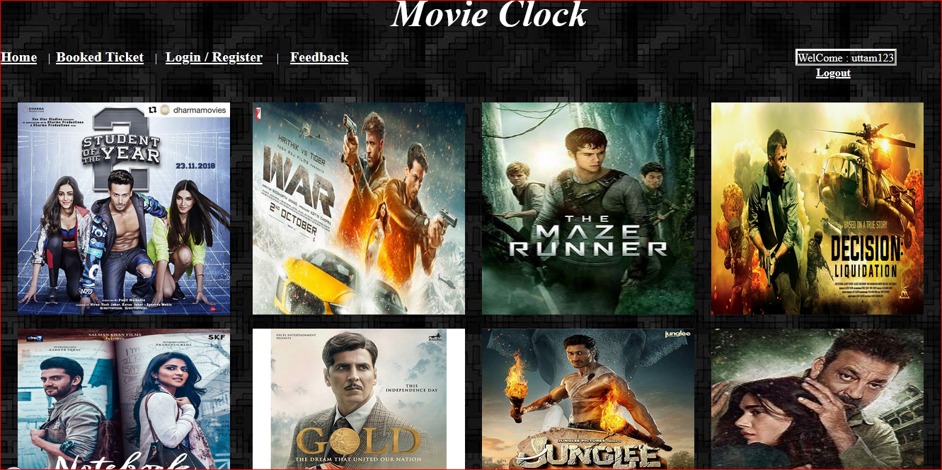

1. ***Login Page***

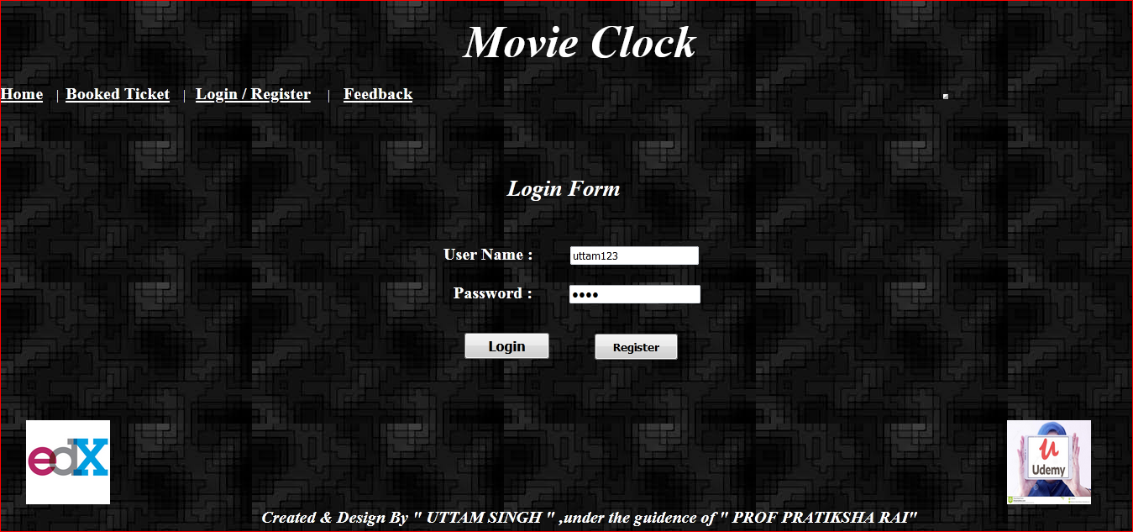

1. ***FeedBack Page:***

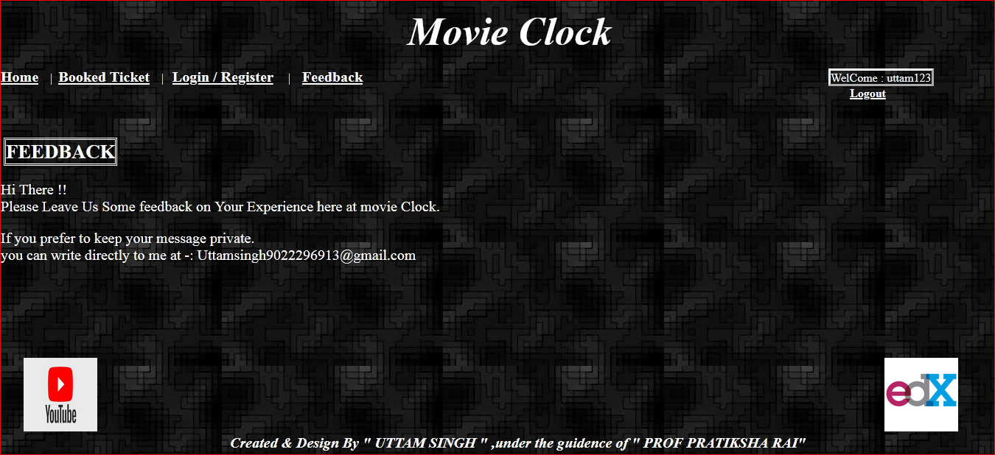

1. ***Registration Page :***

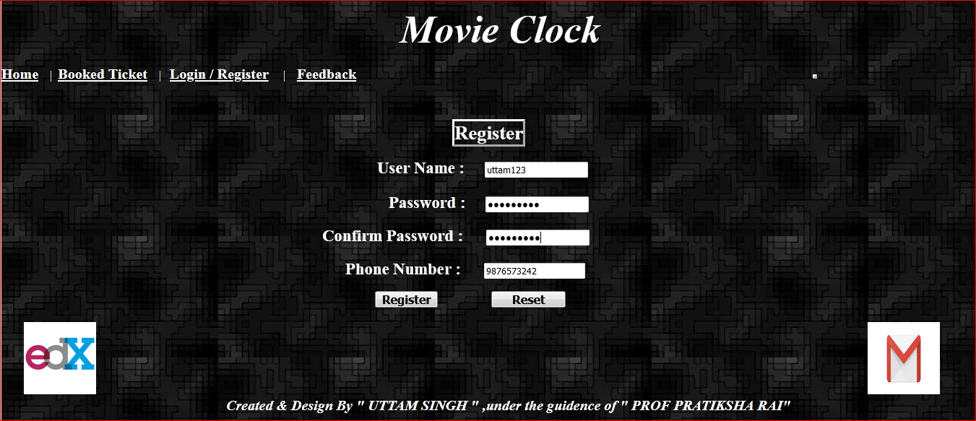

1. ***Ticket Booking Page:***

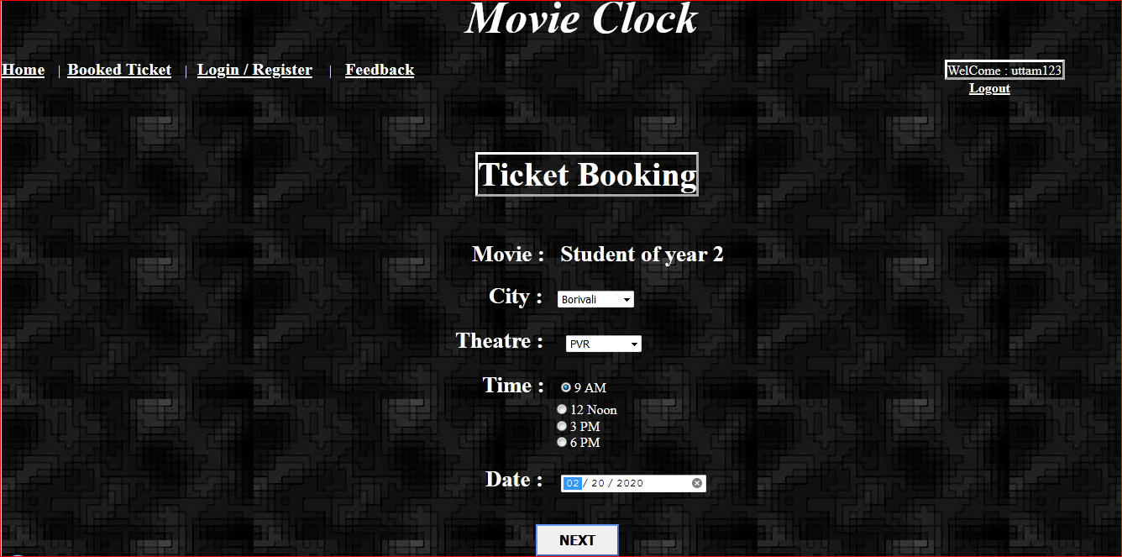

1. ***Confirm Booking Page***

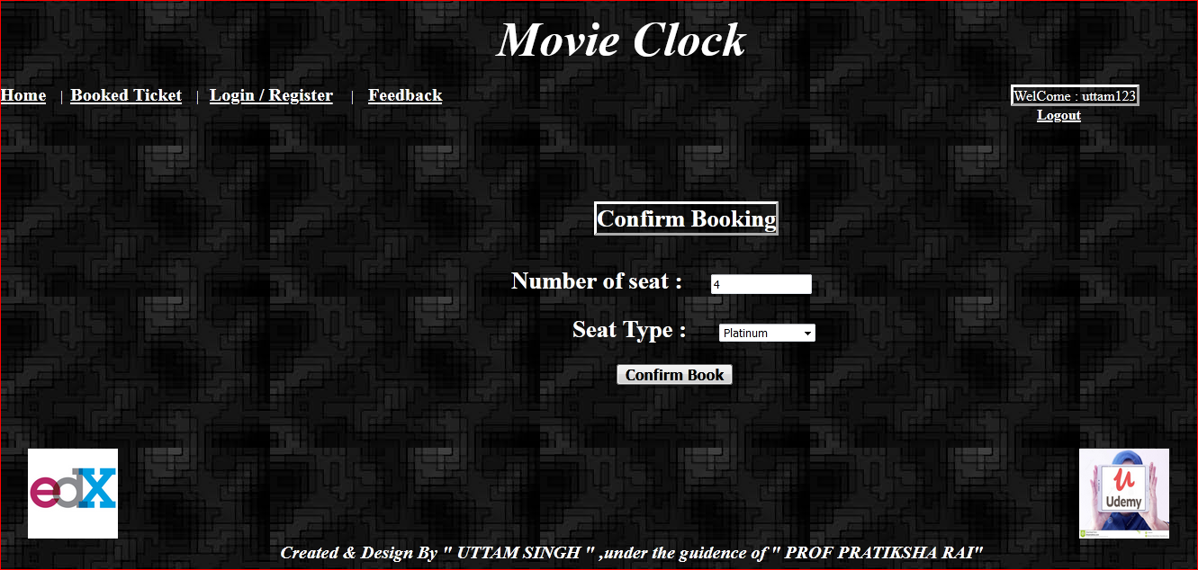

1. ***Final Page***

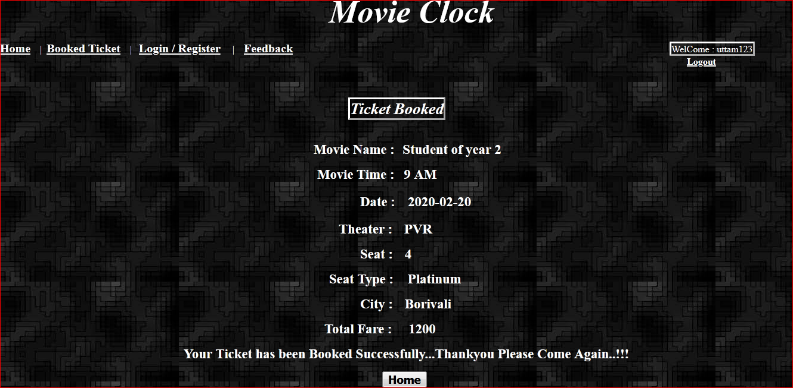

1. ***Booked Tickets Page:***

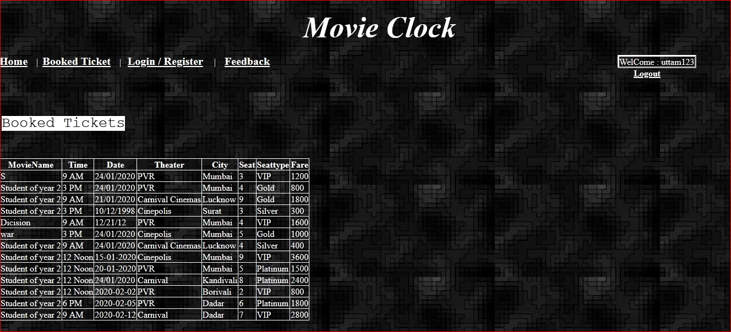

***Database***

***Register Table:***

|  |  |
| --- | --- |
| ***Field name*** | ***Data Type*** |
| *Username* | *Varchar* |
| *Password* | *Varchar* |
| *Confirm Password* | *Varchar* |
| *Phone* | *Varchar* |

***Movie Table:***

|  |  |
| --- | --- |
| ***Field name*** | ***Data Type*** |
| *Theatre* | *Varchar* |
| *City* | *Varchar* |

***Booked Ticket:***

|  |  |
| --- | --- |
| ***Field Name*** | ***Data Type*** |
| *Movie Name* | *Varchar* |
| *Time* | *Varchar* |
| *Date* | *Varchar* |
| *Theater* | *Varchar* |
| *City* | *Varchar* |
| *Seat* | *Varchar* |
| *Seat Type* | *Varchar* |
| *Fare* | *Varchar* |

***USE CASE DIAGRAM***

***Use Case Diagram For Admin :***

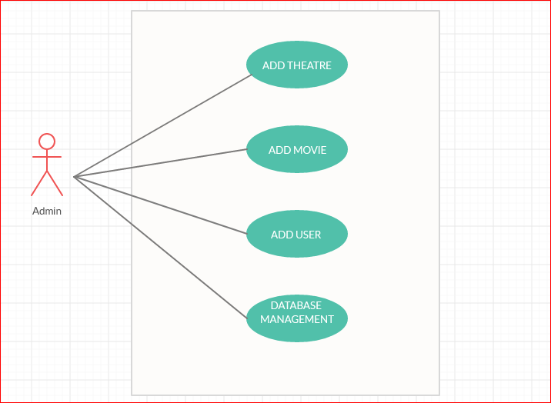

***Use Case Diagram For User :***

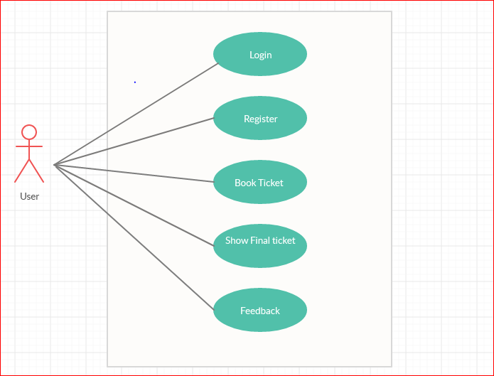

***FUTURE IMPLEMENTATIONS***

1. *Online Payments Options*
2. *Adding Theatre Shows*
3. *Adding More Theatre*
4. *Implementing Web Services*
5. *Mobile App to target Mobile Visitor*
6. *Modify Booked Tickets*

***BIBLIOGRAPHY***

1. [*www.google.com*](http://www.google.com)
2. [*www.youtube.com*](http://www.youtube.com)
3. [*www.lecturenotes.in*](http://www.lecturenotes.in)
4. *https://app.creately.com*
5. *Beginning of ASP.NET, Mac Donald*
6. *Hariti Study Hub – Easy Learn (Youtube)*